CODATA-RDA Research Data Summer School
University of Pretoria – Department of Information Science in collaboration with DIRISA, SADiLaR and NeDICC.

13–24 January 2020
Pretoria, South Africa

Description
The material covered by the programme is fundamental to all areas of research, and thus open to researchers and professionals from all disciplines that deal with significant amounts of research data. The goal is to provide a practical introduction to these topics with some theory and extensive hands-on training.

Costs
The school is heavily sponsored. Successful applicants will be expected to pay a fee of
R1 150 once the application is accepted. This fee includes all training and catering (lunches). Applicants are responsible for their own travel and accommodation arrangements.

Application deadline:
15 October 2019 – extended to 31 October 2019

Online application and further information:
https://www.dirisa.ac.za/CODATA-RDA
ResearchDataSummerSchool-2020/
Females, Social Scientists and participants from developing countries are encouraged to apply
The school provides early career researchers (M-level to postdoc) with the foundational data science skills, which include technical skills and responsible research practices, to enable them to work with their data in an effective and efficient manner required by 21st century research.

Topics
- Open Science
- Introduction to Unix Shell
- Introduction to Git
- Open and Collaborative Research
- Research Data Management
- Data Cleaning – using Open Refine
- Data Analysis and Visualisation – using R
- Data Intensive Social Science
- Author Carpentry
- Information Security
- Machine Learning and Neural Networks
- Research Computational Infrastructure

International Directors
H Shanahan (Royal Holloway University, UK) L Bezuidenhout (University of Oxford, UK)

Local Organisers
A Vahed (DIRISA) | B Peterson, (NWU)
J Steyn (SADiLAR, NWU) | J van Wyk (NeDICC) M Holmner (UP) | M van Deventer (UP)

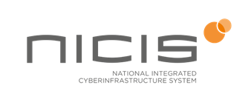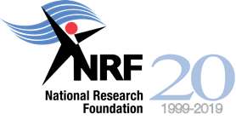
Faculty of Engineering, Built Environment and Information Technology
Fakulteit Ingenieurswese, Bou-omgewing en Inligtingtegnologie / Lefapha la Boetšenere, Tikologo ya Kago le Theknolotši ya Tshedimošo
