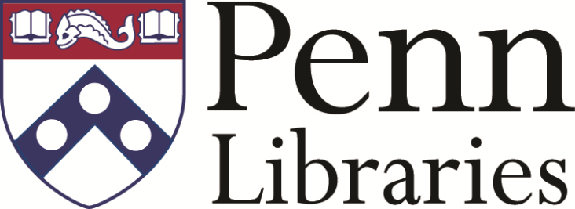

Scholarly Communications Librarian

The Scholarly Communication Librarian provides leadership in promoting scholarly communication initiatives on the Penn campus by developing education programs, providing tools and resources, building a network of campus partners, monitoring trends, promoting open access publication, and advising on copyright, rights retention, and open access.

If you would like to see the complete job description and are interested in the position, please complete our online application at: http://jobs.hr.upenn.edu/postings/11124

Should you have any questions, please contact Penn's Recruitment and Staffing department at recruitment@hr.upenn.edu or (215) 898-7287.
The University of Pennsylvania values diversity and seeks talented students, faculty and staff from diverse backgrounds. The University of Pennsylvania does not discriminate on the basis of race, color, sex, sexual orientation, gender identity, religion, creed, national or ethnic origin, citizenship status, age, disability, veteran status or any other legally protected class status in the administration of its admissions, financial aid, educational or athletic programs, or other University-administered programs or in its employment practices. Questions or complaints regarding this policy should be directed to the Executive Director of the Office of Affirmative Action and Equal Opportunity Programs, Sansom Place East, 3600 Chestnut Street, Suite 228, Philadelphia, PA 19104-6106; or (215) 898-6993 (Voice) or (215) 746-7088 (Fax). http://www.upenn.edu/affirm-action/ . The University of Pennsylvania Libraries is committed to a diverse workforce. To learn more, please visit: http://guides.library.upenn.edu/gold_overview.
We have partnered with HireRight, one of the world's largest background screening providers, to implement employment screening solutions that ensure positive partnerships between Penn and new employees.

